English Grammar: ‘have’ vs ‘have got’

The verb ‘to have’ has an informal equivalent which is very common in everyday English: ‘to have got’. It is only used in the “present simple”. Here are some examples:

Possession:
Formal English Informal English American English
I have a dog. I’ve got a dog. I got a dog.
He has a dog. He’s got a dog.
I don’t have a dog. I haven’t got a dog.
He doesn’t have a dog. He hasn’t got a dog.
Do you have a dog? Have you got a dog?
Does he have a dog? Has he got a dog?
Don’t you have a dog? Haven’t you got a dog?
Doesn’t he have a dog? Hasn’t he got a dog?
Obligation:
Formal English Informal English American English
I have to go. I’ve got to go. I gotta go. / Gotta go.
He has to go. He’s got to go. He’s gotta go.
I don’t have to go. I haven’t got to go. I don’t gotta go.
He doesn’t have to go. He hasn’t got to go. He don’t gotta go.
Do you have to go? Have you got to go? You gotta go?
Does he have to go? Has he got to go? He gotta go?
Don’t you have to go? Haven’t you got to go? Haven’t you gotta go?
Doesn’t he have to go? Hasn’t he got to go? Hasn’t he gotta go?

Recommended video: https://www.youtube.com/watch?v=KZpae3Hh3o4 (11 mins)

Music suggestions:

You’ve got a Friend: https://www.youtube.com/watch?v=BcJbzuyp6VY (5 mins)
I’ve got a Feeling: https://www.youtube.com/watch?v=sKsrLjN5H6Y (6 mins)

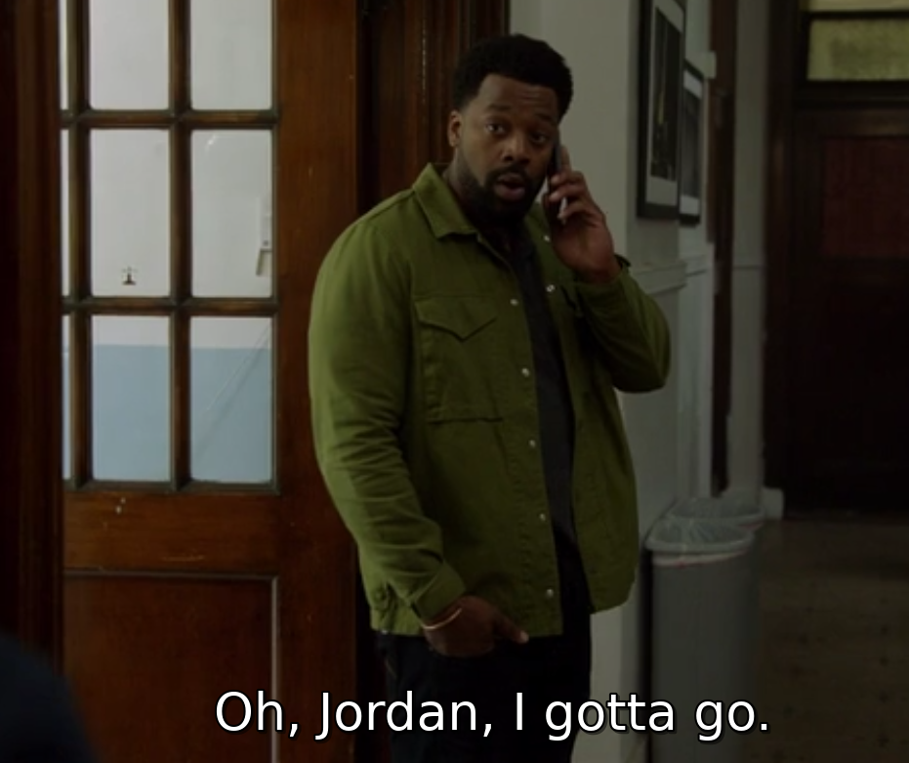
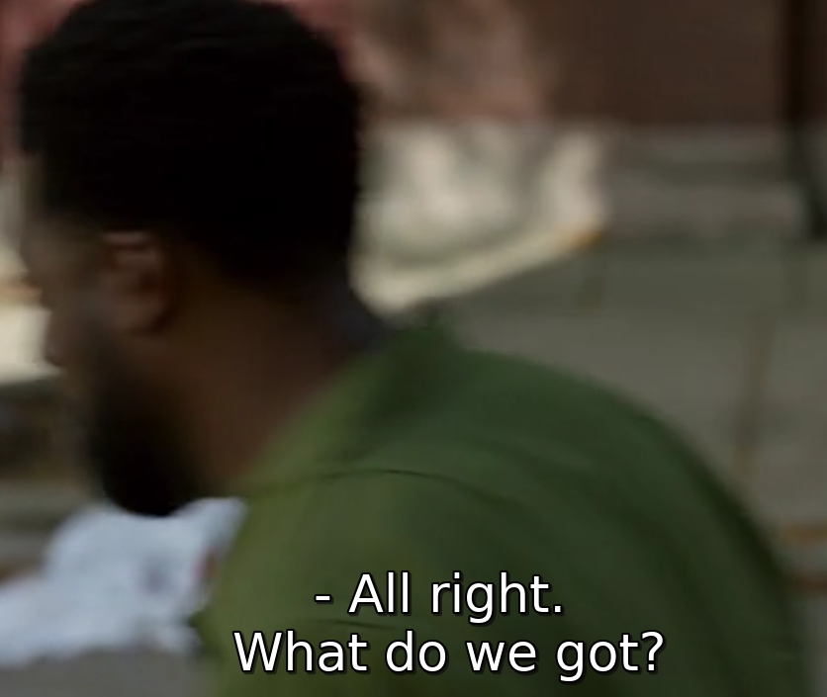
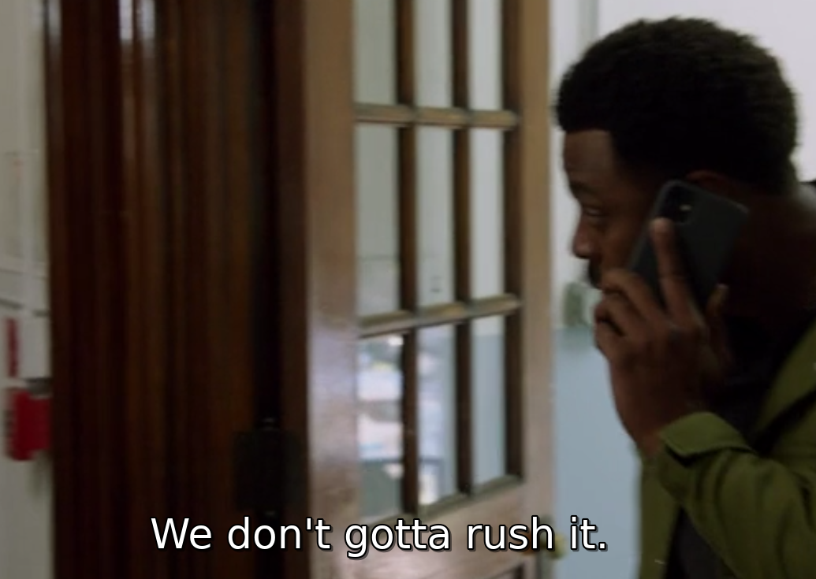
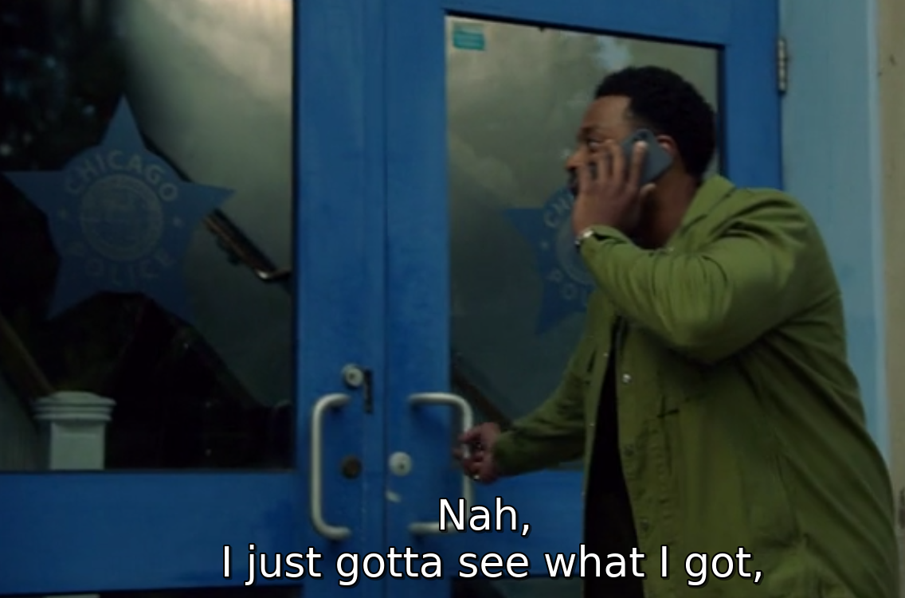
Here are some examples from American TV (Chicago PD):

What it should be:
“Oh, Jordan, I have to go.”

What it should be:
“All right. What do we have?”

What it should be:
“We don’t have to rush it.”

What it should be:
“No, I just have to see what I have.”

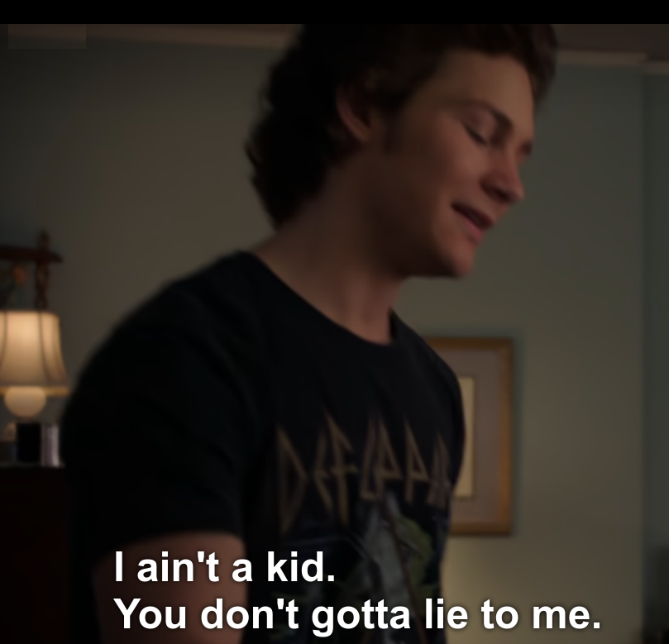
Exercise. Rewrite the following sentences in formal (“correct”) English:
1. He’s got a wig.
_______________________________________________________________________
2. You’ve got an interesting point of view.
_______________________________________________________________________
3. Has he got a new car?
_______________________________________________________________________
4. Haven’t they got two houses?
_______________________________________________________________________
5. I’ve got to start early today.
_______________________________________________________________________
6. Have you got to go already?
_______________________________________________________________________
7. He’s gotta lotta money.
_______________________________________________________________________
8. They gotta go.
_______________________________________________________________________

9.

__________________________________________________________

